**DAILY ONLINE ACTIVITIES SUMMARY**

|  |  |  |  |  |  |  |  |  |
| --- | --- | --- | --- | --- | --- | --- | --- | --- |
| **Date:** | **04/07/2020** | | | | | **Name:** | **AKASH S** | |
| **Sem & Sec** | **4TH&A** | | | | | **USN:** | **4AL18CS004** | |
| **Online Test Summary** | | | | | | | | |
| **Subject** | | **----** | | | | | | |
| **Max. Marks** | | **--** | | **Score** | | | **--** | |
| **Certification Course Summary** | | | | | | | | |
| **Course** | **STATISTICAL METHOD FOR DECISION MAKING** | | | | | | | |
| **Certificate Provider** | | | **GREAT LEARNING** | | **Duration** | | | **7 HOURS** |
| **Coding Challenges** | | | | | | | | |
| **Problem Statement 1: Given an array of integer arr[] and an integer k, the task is to find the median of each window of size k starting from the left and moving towards the right by one position each time.** | | | | | | | | |
| **Status: executed** | | | | | | | | |
| **Uploaded the report in Github** | | | | | **YES** | | | |
| **If yes Repository name** | | | | | <https://github.com/akashacharya786/lockdown-c-coding>  **https://github.com/akashacharya786/lockdown-java-coding** | | | |
| **Uploaded the report in slack** | | | | | **YES** | | | |

**Online Test Summary: Not conducted**

**Online Certification course:**

Name of the course :Statistical method for decision making

Duration: 7 hours

Certificate provider: great learning

Snap shot:

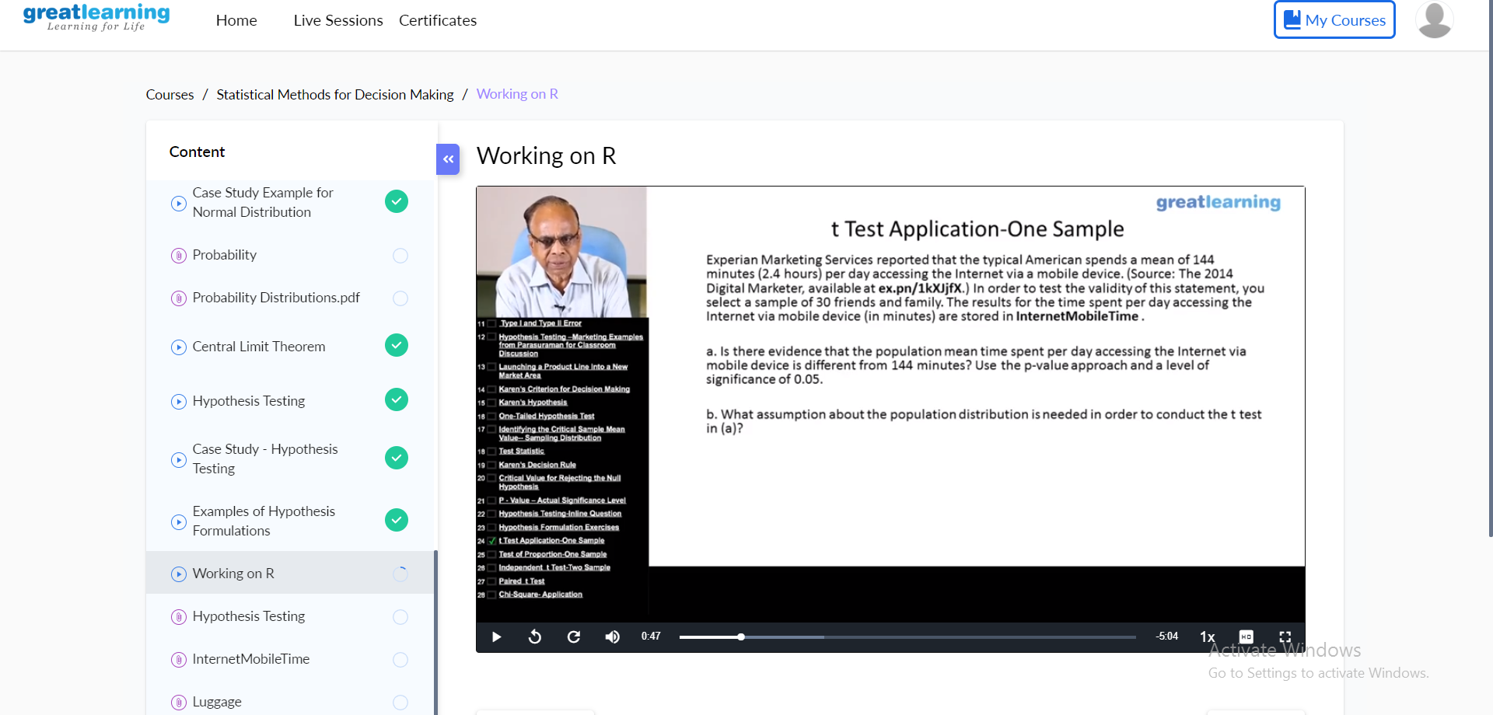

Today I have completed all the chapters.

Online Coding summary:

1. **Given an array of integer arr[] and an integer k, the task is to find the median of each window of size k starting from the left and moving towards the right by one position each time.**

